[Thực hành] Viết Unit Testing cho Spring MVC Controllers

Mục tiêu:
Luyện tập viết Unit Testing trong Spring MVC

Mô tả:
Viết unit testing cho một số phương thức xử lý cơ bản trong controller như findAll(), findById(), add().

Hướng dẫn:
Bước 1:
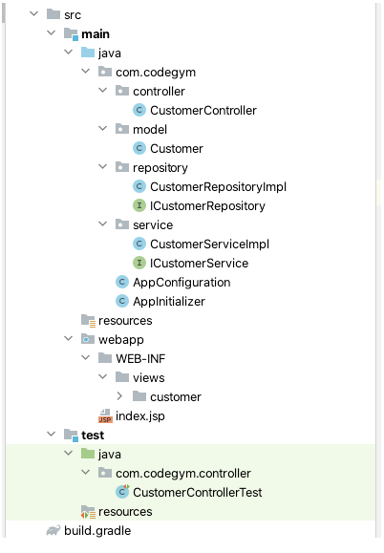
Bổ sung các thư viện cần thiết trong file build.gradle
dependencies {
providedCompile group: 'javax.servlet', name: 'javax.servlet-api', version: '4.0.1'
implementation group: 'org.springframework', name: 'spring-core', version: '5.3.2'
implementation group: 'org.springframework', name: 'spring-context', version: '5.3.2'
implementation group: 'org.springframework', name: 'spring-beans', version: '5.3.2'
implementation group: 'org.springframework', name: 'spring-web', version: '5.3.2'
implementation group: 'org.springframework', name: 'spring-webmvc', version: '5.3.2'
implementation group: 'org.thymeleaf', name: 'thymeleaf-spring5', version: '3.0.11.RELEASE'
implementation group: 'nz.net.ultraq.thymeleaf', name: 'thymeleaf-layout-dialect', version: '2.5.2'
}
Bước 2:
Tạo các file cấu hình:
File AppConfiguration:
package com.codegym;
import com.codegym.repository.CustomerRepositoryImpl;
import com.codegym.repository.ICustomerRepository;
import com.codegym.service.CustomerServiceImpl;
import com.codegym.service.ICustomerService;
import org.springframework.beans.BeansException;
import org.springframework.context.ApplicationContext;
import org.springframework.context.ApplicationContextAware;
import org.springframework.context.annotation.Bean;
import org.springframework.context.annotation.ComponentScan;
import org.springframework.context.annotation.Configuration;
import org.springframework.web.servlet.config.annotation.EnableWebMvc;
import org.springframework.web.servlet.config.annotation.WebMvcConfigurer;
import org.thymeleaf.spring5.SpringTemplateEngine;
import org.thymeleaf.spring5.templateresolver.SpringResourceTemplateResolver;
import org.thymeleaf.spring5.view.ThymeleafViewResolver;
import org.thymeleaf.templatemode.TemplateMode;
@Configuration
@EnableWebMvc
@ComponentScan("com.codegym")
public class AppConfiguration implements WebMvcConfigurer, ApplicationContextAware {
private ApplicationContext applicationContext;
@Override
public void setApplicationContext(ApplicationContext applicationContext) throws BeansException {
this.applicationContext = applicationContext;
}
//Cấu hình Thymleaf
@Bean
public SpringResourceTemplateResolver templateResolver() {
SpringResourceTemplateResolver templateResolver = new SpringResourceTemplateResolver();
templateResolver.setApplicationContext(applicationContext);
templateResolver.setPrefix("/WEB-INF/views");
templateResolver.setSuffix(".html");
templateResolver.setTemplateMode(TemplateMode.HTML);
templateResolver.setCharacterEncoding("UTF-8");
return templateResolver;
}
@Bean
public SpringTemplateEngine templateEngine() {
SpringTemplateEngine templateEngine = new SpringTemplateEngine();
templateEngine.setTemplateResolver(templateResolver());
return templateEngine;
}
@Bean
public ThymeleafViewResolver viewResolver() {
ThymeleafViewResolver viewResolver = new ThymeleafViewResolver();
viewResolver.setTemplateEngine(templateEngine());
viewResolver.setCharacterEncoding("UTF-8");
return viewResolver;
}
@Bean
public ICustomerRepository customerRepository(){
return new CustomerRepositoryImpl();
}
@Bean
public ICustomerService customerService(){
return new CustomerServiceImpl();
}
}
File AppInitializer:
package com.codegym;
import org.springframework.web.servlet.support.AbstractAnnotationConfigDispatcherServletInitializer;
public class AppInitializer extends AbstractAnnotationConfigDispatcherServletInitializer {
@Override
protected Class<?>[] getRootConfigClasses() {
return new Class[]{AppConfiguration.class};
}
@Override
protected Class<?>[] getServletConfigClasses() {
return new Class[]{};
}
@Override
protected String[] getServletMappings() {
return new String[]{"/"};
}
}
Bước 3:
Tạo lớp Customer:
package com.codegym.model;
public class Customer {
private int id;
private String firstName;
private String lastName;
public Customer() {
}
public Customer(int id, String firstName, String lastName) {
this.id = id;
this.firstName = firstName;
this.lastName = lastName;
}
public int getId() {
return id;
}
public void setId(int id) {
this.id = id;
}
public String getFirstName() {
return firstName;
}
public void setFirstName(String firstName) {
this.firstName = firstName;
}
public String getLastName() {
return lastName;
}
public void setLastName(String lastName) {
this.lastName = lastName;
}
}
Bước 4:
Tạo các lớp của tầng Repository:
Interface ICustomerRepository:
package com.codegym.repository;
import com.codegym.model.Customer;
import java.util.List;
public interface ICustomerRepository {
List<Customer> findAll();
Customer add(Customer customer);
Customer findById(int id);
}
Lớp CustomerRepositoryImpl:
package com.codegym.repository;
import com.codegym.model.Customer;
import java.util.ArrayList;
import java.util.HashMap;
import java.util.List;
import java.util.Map;
public class CustomerRepositoryImpl implements ICustomerRepository{
private static final Map<Integer, Customer> customers;
static {
customers = new HashMap<>();
customers.put(1, new Customer(1, "Hoang", "Kien"));
customers.put(2, new Customer(2, "Lam", "Thai"));
}
@Override
public List<Customer> findAll() {
return new ArrayList<>(customers.values());
}
@Override
public Customer add(Customer customer) {
customers.put(customer.getId(), customer);
return customer;
}
@Override
public Customer findById(int id) {
return customers.get(id);
}
}
Bước 5:
Tạo các lớp của tầng service:
Interface ICustomerService:
package com.codegym.service;
import com.codegym.model.Customer;
import java.util.List;
public interface ICustomerService {
List<Customer> findAll();
Customer add(Customer customer);
Customer findById(int id);
}
Lớp CustomerServiceImpl:
package com.codegym.service;
import com.codegym.model.Customer;
import com.codegym.repository.ICustomerRepository;
import org.springframework.beans.factory.annotation.Autowired;
import java.util.List;
public class CustomerServiceImpl implements ICustomerService{
@Autowired
private ICustomerRepository customerRepository;
@Override
public List<Customer> findAll() {
return customerRepository.findAll();
}
@Override
public Customer add(Customer customer) {
return customerRepository.add(customer);
}
@Override
public Customer findById(int id) {
return customerRepository.findById(id);
}
}
Bước 6:
Tạo lớp CustomerController:
package com.codegym.controller;
import com.codegym.model.Customer;
import com.codegym.service.ICustomerService;
import org.springframework.beans.factory.annotation.Autowired;
import org.springframework.stereotype.Controller;
import org.springframework.ui.Model;
import org.springframework.validation.BindingResult;
import org.springframework.web.bind.annotation.*;
import java.util.ArrayList;
import java.util.List;
@Controller
@RequestMapping("/customer")
public class CustomerController {
@Autowired
private ICustomerService customerService;
@GetMapping("")
public String getCustomers(Model model){
List<Customer> customers = new ArrayList<>();
customers = customerService.findAll();
model.addAttribute("customers",customers);
return "/customer/list";
}
@GetMapping("/{id}")
public String getCustomerById(@PathVariable("id") int id, Model model){
Customer customer = customerService.findById(id);
model.addAttribute("customer", customer);
return "/customer/detail";
}
@GetMapping("/create")
public String createForm(Model model){
model.addAttribute("customer", new Customer());
return "/customer/create";
}
@PostMapping("/save")
public String save(@ModelAttribute("customer") Customer customer, Model model,BindingResult result){
if (result.hasErrors()){
System.out.println("Error!!!");
}
customerService.add(customer);
model.addAttribute("customer", new Customer());
return "/customer/create";
}
}
Bước 7:
Tạo các view:
View list.html:
<!DOCTYPE html>
<html lang="en" xmlns:th="http://www.thymeleaf.org">
<head>
<meta charset="UTF-8">
<title>Title</title>
</head>
<body>
<h1>customers</h1>
<div th:each="c : ${customers}">
<p th:text="${c.firstName}"></p>
<p th:text="${c.lastName}"></p>
<p th:text="----------"></p>
</div>
</body>
</html>
View detail.html
<!DOCTYPE html>
<html lang="en" xmlns:th="http://www.thymeleaf.org">
<head>
<meta charset="UTF-8">
<title>Title</title>
</head>
<body>
<h1>customer detail</h1>
<p th:text="${customer.firstName}"></p>
<p th:text="${customer.lastName}"></p>
<p th:text="----------"></p>
</body>
</html>
View create.html
<!DOCTYPE html>
<html xmlns:th="http://www.thymeleaf.org">
<head>
<meta charset="utf-8" />
<title>Spring Customer</title>
</head>
<body>
<h3>Add Customer</h3>
<p>
<a th:href="@{/customer}">
Back to customer list
</a>
</p>
<div id="form">
<form th:action="@{/customer/save}" th:object="${customer}"
method="POST" novalidate="novalidate">
<input type="hidden" th:field="*{id}"/>
<div>
<label>First Name</label>
<input type="text" th:field="*{firstName}"/>
</div>
<div>
<label>Last Name</label>
<input type="text" th:field="*{lastName}"/>
</div>
<input type="submit" value="Save"/>
</form>
</div>
</body>
</html>
Bước 8:
Cấu hình, chạy dự án và kiểm tra các chức năng hoạt động tốt.
Bước 9:
Bổ sung các thư viện cần thiết trong file build.gradle để viết unit testing:
implementation group: 'org.junit.jupiter', name: 'junit-jupiter-engine', version: '5.7.0'
implementation group: 'org.junit.platform', name: 'junit-platform-commons', version: '1.7.0'
implementation group: 'org.junit.platform', name: 'junit-platform-launcher', version: '1.7.0'
implementation group: 'org.springframework', name: 'spring-test', version: '5.3.2'
implementation group: 'com.github.sbrannen', name: 'spring-test-junit5', version: '1.2.0'
implementation group: 'org.mockito', name: 'mockito-all', version: '1.10.19'
implementation group: 'org.hamcrest', name: 'hamcrest-all', version: '1.1'
implementation group: 'org.hamcrest', name: 'hamcrest-core', version: '1.3'
Bổ sung script trong file build.gradle để gradle chạy test
test {
useJUnitPlatform()
testLogging {
events "PASSED", "STARTED", "FAILED", "SKIPPED", "STANDARD_OUT", "STANDARD_ERROR"
}
afterTest { desc, result ->
println "Testing ${desc.name} [${desc.className}]: ${result.resultType}"
}
reports {
html.enabled = true
}
}
Tạo mới một Gradle Configuration cho IntelliJ, với task là "Test":
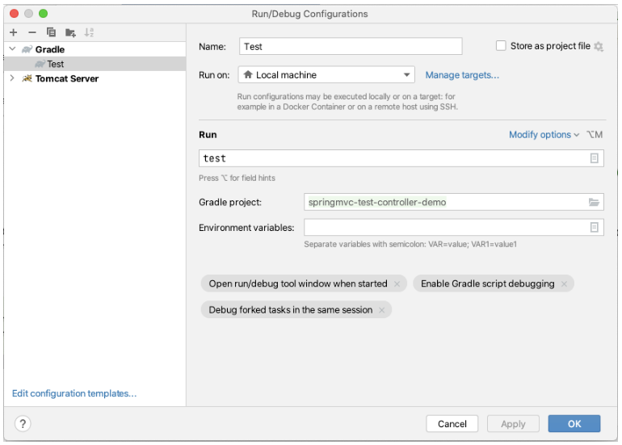
Thử chạy configuration để chắc chắn không có lỗi xảy ra.
Tạo mới một kiểm thử đơn vị, lưu ý đặt file mã tại thư mục test thay vì source.
Lưu ý: nếu bên trong thư mục test chưa có thư mục con là java thì hãy tạo thêm thư mục java để có thể tạo được các class bên trong. Chuột phải vào thư mục test->New->Directory và gõ java
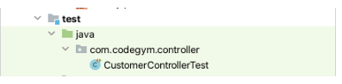
Bổ sung repo cho thư viện spring-test-junit5 trong file build.gradle:
repositories {
mavenCentral()
maven { url 'https://jitpack.io' }
}
Bước 10:
Tạo lớp CustomerControllerTest:
package com.codegym.controller;
import com.codegym.model.Customer;
import com.codegym.service.ICustomerService;
import com.codegym.service.CustomerServiceImpl;
import org.junit.jupiter.api.BeforeEach;
import org.junit.jupiter.api.Test;
import org.mockito.ArgumentCaptor;
import org.mockito.InjectMocks;
import org.mockito.Mockito;
import org.mockito.MockitoAnnotations;
import org.springframework.http.MediaType;
import org.springframework.test.context.web.WebAppConfiguration;
import org.springframework.test.web.servlet.MockMvc;
import org.springframework.test.web.servlet.setup.MockMvcBuilders;
import java.util.Arrays;
import static org.hamcrest.Matchers.*;
import static org.hamcrest.Matchers.is;
import static org.junit.jupiter.api.Assertions.*;
import static org.mockito.Mockito.*;
import static org.mockito.Mockito.verifyNoMoreInteractions;
import static org.springframework.test.web.servlet.request.MockMvcRequestBuilders.get;
import static org.springframework.test.web.servlet.request.MockMvcRequestBuilders.post;
import static org.springframework.test.web.servlet.result.MockMvcResultMatchers.*;
import static org.springframework.test.web.servlet.result.MockMvcResultMatchers.model;
@WebAppConfiguration
public class CustomerControllerTest {
private ICustomerService customerService = Mockito.mock(CustomerServiceImpl.class);
private MockMvc mockMvc;
@InjectMocks
private CustomerController customerController;
@BeforeEach
void setUp() {
MockitoAnnotations.initMocks(this);
mockMvc = MockMvcBuilders
.standaloneSetup(customerController)
.build();
}
@Test
public void find_All_Test() throws Exception{
Customer first = new Customer(1,"Nguyen","Tung");
Customer second = new Customer(2,"Hoang","Nam");
when(customerService.findAll()).thenReturn(Arrays.asList(first, second));
mockMvc
.perform(get("/customer"))
.andExpect(status().isOk())
.andExpect(view().name("/customer/list"))
.andExpect(forwardedUrl("/customer/list"))
.andExpect(model().attribute("customers", hasItem(
allOf(
hasProperty("id", is(1)),
hasProperty("firstName", is("Nguyen")),
hasProperty("lastName", is("Tung"))
)
)))
.andExpect(model().attribute("customers", hasItem(
allOf(
hasProperty("id", is(2)),
hasProperty("firstName", is("Hoang")),
hasProperty("lastName", is("Nam"))
)
)));
verify(customerService, times(1)).findAll();
verifyNoMoreInteractions(customerService);
}
@Test
public void find_By_Id_Test() throws Exception {
Customer found = new Customer(1,"Nguyen","Tung");
when(customerService.findById(1)).thenReturn(found);
mockMvc
.perform(get("/customer/{id}", 1))
.andExpect(status().isOk())
.andExpect(view().name("/customer/detail"))
.andExpect(forwardedUrl("/customer/detail"))
.andExpect(model().attribute("customer", hasProperty("id", is(1))))
.andExpect(model().attribute("customer", hasProperty("firstName", is("Nguyen"))))
.andExpect(model().attribute("customer", hasProperty("lastName", is("Tung"))));
verify(customerService, times(1)).findById(1);
verifyNoMoreInteractions(customerService);
}
@Test
public void add_Test() throws Exception {
Customer added = new Customer(1,"Nguyen","Tung");
when(customerService.add(isA(Customer.class))).thenReturn(added);
mockMvc
.perform(post("/customer/save")
.contentType(MediaType.APPLICATION_FORM_URLENCODED)
.param("firstName", "Nguyen")
.param("lastName", "Tung")
.sessionAttr("customer", new Customer())
)
.andExpect(status().isOk())
.andExpect(view().name("/customer/create"));
ArgumentCaptor<Customer> formObjectArgument = ArgumentCaptor.forClass(Customer.class);
verify(customerService, times(1)).add(formObjectArgument.capture());
verifyNoMoreInteractions(customerService);
Customer formObject = formObjectArgument.getValue();
assertEquals(formObject.getFirstName(), "Nguyen");
assertEquals(formObject.getLastName(), "Tung");
}
}
Trong đó:
Bean customerService sẽ không được tạo thật mà được "mock" (giả tạo). Mock bean này bằng cách tạo một class cấu hình test.
@InjectMocks annotation cho phép chúng ta giả lập đối tượng customerController trong lớp CustomerControllerTest
@BeforeEach annotation được sử dụng để báo hiệu rằng phương thức setUp() phải được thực thi trước mỗi phương thức @Test trong lớp hiện tại.
Unit Test cho ba phương thức controller gồm findAll(), findById, add() (Cách viết các unit test có thể xem lại tại bài đọc: https://james.codegym.vn/mod/page/view.php?id=12683)
Bước 11:
Chạy chương trình ở chế độ test và kiểm tra unit test. Kết quả:
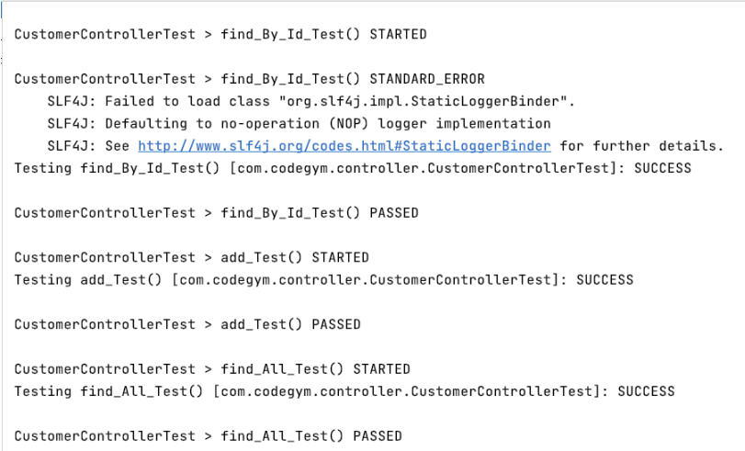
Thử thay đổi mã nguồn của các phương thức controller để test fail.
Mã nguồn tham khảo: https://github.com/codegym-vn/spring-test-controller
Hướng dẫn nộp bài:
- Up mã nguồn lên github
- Paste link github vào phần nộp bài
Last modified: Sunday, 22 August 2021, 3:59 PM

